**Component 1: Emergency Room System (ER)**

**1. Patients arrive at the emergency room with different health problems, and each patient is served according to their arrival time, following an "in, first-served first" (FIFO) approach. Draw and illustrate how such a graph will help deal with patients in the emergency room.**

Emergency room (ER) management can be challenging, especially when it comes to ensuring patients are seen in the order in which they arrive. To use this efficiently and fairly, using the Queue data structure is very efficient. Queue operates on the first-in, first-check-out (FIFO) principle, which means that the first person to arrive is the first to be served. This system maintains organization and justice. In the following sections, I will explain how we manage the process of adding patients to Queue He then served them, explaining how this system helps keep the emergency room running smoothly.

**FIFO Principle**

The FIFO principle (first enter, exit first) means seeing patients in the exact order of their arrival, ensuring fairness and efficiency. Following this principle, the emergency room system ensures that no one is skipped or taken out of their role. This structured approach helps in managing the flow of patients smoothly and enhances the overall experience by being clear and fair. The FIFO principle is fundamental to ensuring that the first patient to arrive is the first to be served, keeping the process fair and straightforward.

**Add to Tail (Enqueue)**

When a patient arrives at the emergency room, they are added to the end of the queue, or queue, in a process called adding to Queue.This is important because it keeps the order of arrival clear. For example, if patient A arrives first, he goes to the front of the class. When patient B arrives, he goes behind patient A. Then patient D and patient C join in that order. This step-by-step addition ensures that everyone knows where they are and will be seen in turn.

**Remove from Queue (Dequeue)**

Removing from Queue (Dequeue) is the process of taking a patient from the front of the row when it is their turn to see them. This step is crucial for justice. The patient who has been waiting for the longest is served first. For example, patient A, who is at the front of the class, will be taken for treatment first. After patient A is served, patient B moves to the front, then patient D and finally patient C. This organized system ensures that each patient is treated in the order of their arrival.

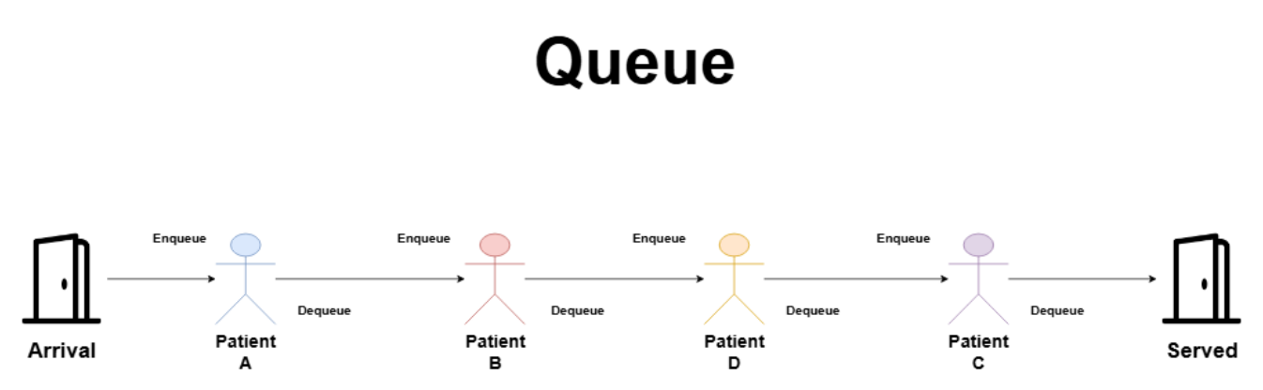

**Explanation of the emergency room system**

**Patient Arrival:**

When patients arrive at the emergency room (ER), they must be managed in the order in which they arrived. This is the initial point where each patient enters the system. When the patient arrives, their details are taken and added to the queue list. For example, when patient A arrives, he is first in line, and then other patients follow.

**Queue list operation:**

The process of making a queue list is crucial because it ensures that each patient is added to the end of the queue list. This means that when each patient arrives, they are placed at the back of the queue menu. For example, after Patient A arrives, when Patient B arrives, they are placed in a queue behind Patient A. This process continues with Patient D and Patient C in the queue in the order they arrive, while maintaining the input sequence.

**Forming a queue list:**

As more patients arrive, the queue list begins to form. This queue list represents the waiting line for patients based on their arrival time. It looks like this: [Patient A]-> [Patient B]-> [Patient D]-> [Patient C]. This structured formation is essential to effectively manage patient flow and ensures that no patient is skipped.

**Waiting for the patient:**

Once they are on the queue, patients wait for their turn to be served. The position in the queue list determines the order of the service. Patient A, the first, is waiting in front, followed by Patient B, Patient D, and finally Patient C. This queue period is managed through a queue menu, ensuring that each patient knows where they are and can be attended sequentially.

**Tail Process:**

Queue cancellation is the process of removing a patient from the front of the queue list when it is their turn to receive service. This means that a patient who has waited longer is the first to be treated. For example, Patient A, located in front, will be placed in the queue list first and taken for treatment. After patient A, patient B moves to the front of the queue, and is ready for service afterwards.

**Patient Service:**

Once the patient is placed in the queue, he is taken care of by the medical staff. This is the actual service part in which the patient's health problems are addressed. For example, after being placed in a queue, Patient A receives the necessary medical treatment. This process ensures that each patient is served in the exact order of arrival, maintaining justice and efficiency in the emergency room.

**Explanation for each patient**

**Patient A:**

Patient A arrives first and is placed in the queue list immediately. They take first place in the queue list, making them the first to be served. Patient A waits in front until it's their turn to be looked after. Once their turn comes, they are placed in a queue and receive medical care first.

**Patient B:**

Patient B arrives in second place and is placed just behind Patient A in the queue list. They occupy the second place and wait behind patient A. When patient A is served and placed in a queue, Patient B moves to the front and becomes next in the queue to which the service will be served. They receive medical care after Patient A.

**Patient D:**

Patient D reaches third place and joins the queue list behind Patient B. It occupies third place in the queue. Patient D is waiting for their turn as the service is provided to Patient A and Patient B. When it's their turn, they step forward while others line up in front of them, eventually receiving medical treatment.

**Patient C:**

Patient C is the fourth to arrive and occupies the last place in the queue. They wait patiently behind Patient D. As the queue progresses as patients are served and placed in the queue, patient C moves forward. Eventually, when it is their turn, they receive medical care, ensuring they receive the service in the order they arrived.

Using a queue list system to handle the flow of patients in the emergency room (ER) is efficient and fair. The queue list follows FIFO, which means patients are treated in the order in which they arrive. This systematic approach to adding a (queue) and a service (queue list) for patients keeps everything running smoothly. It ensures that the doctor sees each patient based on the time of arrival. By adhering to the FIFO rule, the emergency department can efficiently manage patient traffic, ensuring that everyone receives fair and timely care. This system is essential to keeping things organized and fair in a fast-paced emergency room environment.

**--**

**Front :**

* The front of the queue is where the items are removed from (queued).
* It refers to the oldest item in the queue, which has been around for the longest time and is the next to be addressed.
* In many queue applications, when you perform a dequeue operation, the forward cursor is moved to the next item in the sequence.

**Rear Rear:**

* The back of the queue is where new items are added (queue).
* Indicates the most recent item added to the queue.
* In many queue applications, when you perform a queue operation, the back cursor is moved to the last new item in the sequence.

**2- Use a queue to deal with patient requests, taking into account its characteristics and processes.**

**Code**

**Input patients:**

**Output:**

**Clarification:**

**Patient Category:**

The patient is represented by a name and a sign indicating whether his condition is critical.

**Main method:**

**Two queues are used**: one for critically ill patients (critical waiting list) and one for non-critical patients (patient waiting list).

The user is asked to enter the names of patients and their critical condition so that they type "exit".

Depending on the patient's critical condition, they are added to either the critical waiting list or the patient waiting list.

**Patient Treatment:**

Critically ill patients are cared for first by voting from the critical waiting list.

Once all critically ill patients are present, non-critically ill patients are cared for in the order they are added to the patient waiting list.

This code ensures that critically ill patients are prioritized while maintaining the order of arrival for non-critically ill patients.

**3. What if the user tries to eject (dequeue) an empty queue? Discuss how you would check such a case, and create a test case and a way to address errors for that specific case.**

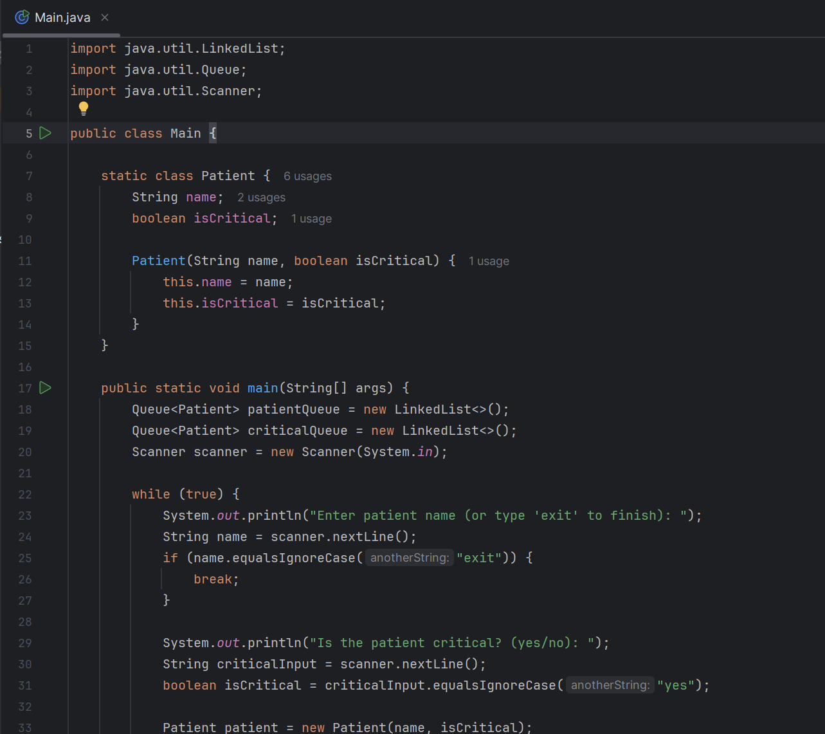

**INPUT PATIENT**

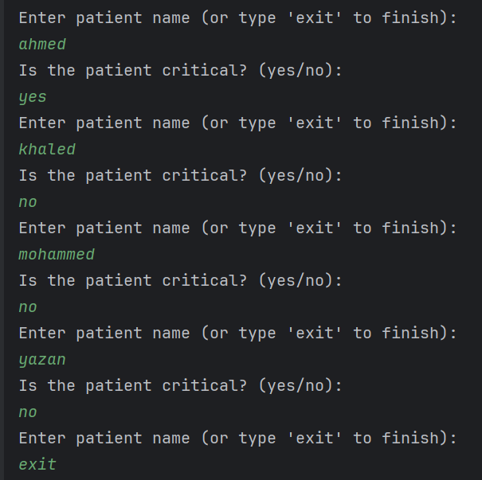

**OUTPUT**

**Clarification :**

**Error handling method:**

The ProcessQueue method checks if the queue is empty before attempting to cancel the queue.

If the queue is empty, a message will be printed indicating that there are no more patients in the queue.

**Process queue:**

This method takes a queue and a string representing the type of patients (critical or non-critical) as arguments.

He constantly checks if the queue is empty and treats patients until the queue is empty.

**Main method:**

The queue process calls for both the critical queue and the patient queue.

**Test case and implementation**

**To test error handling, you can run the program and follow these steps:**

**Data Entry:**

Add a few critically ill and non-critical patients.

Type "exit" to stop adding patients and start queue processing.

**Queue from empty queue:**

The program should handle the situation where queues become empty and print the appropriate messages without throwing any exceptions.

**4- Based on the code you developed, and the previous explanation, show how the queue you implemented deals with emergency room patient requests effectively.**

### Handling an attempt to remove an item from an empty queue

In an emergency (ER) system, efficient queue management is crucial, especially when dealing with critically ill and non-critical patients. One important scenario to deal with is trying to remove an item from an empty queue. This situation can occur if all patients are already present or if the queue starts empty. Handling this error correctly ensures that the app stays robust and easy to use.

### Check for an empty queue

When executing the queue, it is important to check whether the queue is empty before attempting to remove an item. This can be achieved using the isEmpty() method provided by most queue implementations. The isEmpty() method returns true if the queue contains no items, and false otherwise. By including this check, we can prevent errors and provide useful feedback to the user.

Here's an analysis of how to check for an empty queue:

1. **Use the isEmpty()** method: Before calling the dequeue method, check if the queue is empty.
2. **Conditional check:** If the queue is empty, deal with this scenario by providing an appropriate message or by taking a specific action.

### Implement a test case

To ensure that error handling is effective, we need to implement test cases that simulate the scenario of removing an item from an empty queue. This includes the following steps:

1. **Initial setup**: Initialize the queue and make sure it is empty at the beginning of the test.
2. **Try to remove an item**: Try to remove an item from the empty queue.
3. **Behavior monitoring**: Verify that the system recognizes the empty queue and handles the case properly without throwing exceptions.

### Error handling method

Creating a bug handling method specifically for this case involves adding checks and messages to notify the user about the empty queue. Here's how this can be structured:

1. **Scan before removal**: Always check that the queue is not empty before attempting to remove an item.
2. **Useful message**: If the queue is empty, print a message stating that there are no patients to treat.
3. **Return safely**: Make sure the method returns safely without performing any further operations.

### Detailed analysis and discussion

#### **1. Check for an empty queue**

The first step in dealing with an empty queue scenario is to check if the queue is empty using the isEmpty() method. This is a simple and effective method for determining the status of a queue. Including this check before any removal ensures that the system can respond appropriately without attempting to perform invalid operations.

#### **2. Implement a test case**

Error handling testing involves initializing the queue and simulating the process of removing an item when the queue is empty. By running this test, developers can observe the behavior of the system and ensure that it handles the state as expected. This includes checking that the system prints a message indicating that the queue is empty and does not attempt to remove any items. This test is important to ensure the strength of the application and prevent unexpected crashes during actual use.

**Example of a test case**:

* **Setup**: Initialize an empty queue.
* **Action**: You try to remove an item.
* **Expected result**: The system should print a message like "There are no more patients in the waiting list" and return safely without any errors.

#### **3. Error handling method**

To effectively address this scenario, the error handling method can be designed as follows:

* **Method structure**: Create a method that handles the queue. Before performing the removal operation, check if the queue is empty.
* **Conditional logic**: Use an if statement to check the result of isEmpty(). If true, print a useful message and exit the method.
* **Smooth processing**: Make sure no additional operations are performed on the empty queue, preventing potential errors and ensuring that the system remains in a stable state.

### The bottom line

Dealing with the scenario where a user tries to remove an item from an empty queue is essential to maintaining the strength and ease of use of the emergency (ER) system. By including checks using the isEmpty() method, implementing comprehensive test cases, and designing a clear error handling method, developers can ensure that the system handles these cases safely. This not only prevents errors at runtime but also provides a better user experience by informing users of the queue status and ensuring that the application remains reliable under various conditions.

**5- Evaluate the complexity of the following operations performed on the patient queue: Enqueue, Dequeue, getFirst, getLast, isEmpty. Discuss its convergent complexity and how it is calculated.**

### Assess the complexity of queue operations

In this section, I will assess the complexity of the various operations performed on the patient queue: Enqueue, Dequeue, getFirst, getLast, and isEmpty. We will discuss its asymptotic complexity and explain how to calculate it in detail. Understanding these complexities is essential to ensure efficient and efficient queuing management in an emergency room (ER) environment.

### Queue Operations Explained

#### **Add a patient Enqueue**

The Enqueue process adds a patient to the end of the queue. In Java, we use LinkedList which provides a method called addLast() to append an element to the end of the list.

* **Operation**: Adds a patient to the end of the queue.
* **Explanation**: This method involves adding an item at the end of a linked list, which only requires modifying some pointers. No need to browse the list or move any items, making it straightforward and time-consistent. The process begins by checking if the list is full, which is usually a concern in static data structures such as arrays and not in dynamic structures such as linked lists. The element is then added by modifying the pointers, ensuring that the new element indicates to null (because it is now the last element) and the previous last element refers to the new element. This operation is performed smoothly at a fixed time, regardless of the number of items in the Queue.
* **Complexity**: O(1) - This means that it takes a fixed time regardless of the size of the queue. Efficiency is essential in a real-time system such as the emergency room, where fast and predictable performance is essential to effectively manage incoming patients. In practice, this system allows to handle a continuous flow of patients without any deterioration in performance, ensuring that patients are added to the queue quickly when they arrive.

#### **Remove a Dequeue patient**

The Dequeue process removes a patient from the front of the Queue. With LinkedList, we use the poll() method to remove and return the first item from the list.

* **Operation**: Removes a patient from the front of the Queue.
* **Explanation**: Removing the first item involves updating the header pointer to point to the next item in the list. This is a straightforward process that doesn't depend on the size of the list, making it efficient and fast. The method starts by checking if the list is empty to avoid downflow situations. If not, the head pointer is moved to the next item, effectively removing the first item. This process is crucial to maintaining the order of patient service in the emergency room, ensuring that the first patient to arrive is the first to be Service. The constant complexity of this process ensures that each patient is served quickly, which is vital in an emergency environment where delays can have serious consequences.
* **Complexity**: O(1) – This ensures that patients are served in a timely manner, which is essential to maintaining the flow and efficiency of the emergency room system. Expected performance allows medical professionals to effectively manage patient flows, ensuring that there are no bottlenecks or delays in patient care.

#### **Retrieve the first getLast patient**

The getFirst process retrieves the patient in the front of the queue without removing it. This can be done using the peek() method in LinkedList.

* **Operation**: retrieves the patient in the front of the queue without removing it.
* **Explanation:** Accessing the first item in a linked list is simple because the header pointer points directly to the first node. No need to browse or modify the list. This method checks if the list is empty and if not, returns the first item. This process is especially useful for checking the next patient in the line without modifying the queue, allowing employees to prepare for the next case while still dealing with the current case. This helps in effective management by providing access Fast to the next patient in line, ensuring that the workflow is smooth and uninterrupted.
* **Complexity**: O(1) – This ensures that the next patient is verified to be served quickly, which is important for prioritizing and managing patient care in the emergency room. By providing immediate access to the next patient, this process helps maintain a continuous flow of patient management, ensuring there is always a clear understanding of the Queue status .

#### **Retrieve the last patient getLast**

The getLast process retrieves the patient at the end of the queue without removing it. In LinkedList, the getLast() method returns the last item of the list.

* **Operation**: Retrieves the patient at the end of the queue without removing it.
* **Explanation**: This process may require browsing from the last header to node in the implementation of a basic linked list. However, LinkedList in Java is configured to provide direct access to the last element. The method ensures that the tail indicator is always accessible, making retrieving the last item effective. This process is useful for various administrative tasks, such as checking the length of the queue and managing patient expectations. By knowing the last patient in Queue, employees can estimate times better queue and manage resources accordingly.
* **Complexity**: O(1) - This provides quick access to the last patient in Queue, which is useful for various administrative tasks, such as checking the length of the Queue and managing patient expectations. The constant complexity of this process ensures that this information is always quickly available, contributing to effective patient management and resource allocation.

#### **Check if Queue is empty isEmpty**

The isEmpty process checks if Queue contains any patients. This can be done using the isEmpty() method in LinkedList.

* **Operation**: Checks if Queue is empty.
* **Explanation**: Checking if a list is empty involves simply evaluating whether the header pointer is null or checking the size of the list. There are no complex browsing or calculations involved, making it a very efficient process. The method directly returns a Boolean value that indicates the void state in Queue. This process is necessary to quickly determine the Queue state , allowing employees to make informed decisions about patient management and resource allocation. See if Queue Empty helps with planning and can push employees to prepare for the arrival of new patients or focus on other tasks if Queue is empty.
* **Complexity**: O(1) - This ensures that the Queue status is quickly identified , facilitating better management and allocation of resources in the emergency room. The constant complexity of this process ensures that employees always have an immediate understanding of the Queue status , which is vital for effective management in a dynamic and high-pressure environment such as an emergency room.

### Complexity table

|  |  |  |  |
| --- | --- | --- | --- |
| **Explain** | **Time** | **description** | **Operation** |
| **Add directly to the end of the list by modifying the indicators** | The(1) | Add a patient to the end of Queue | Enqueue |
| **Remove directly from the front of the list by updating the header indicator** | The(1) | Remove a patient from the front of the queue | **Dequeue** |
| **Access the first item directly via the header pointer** | The(1) | Retrieving the first patient | getFirst |
| **Direct access to the last item(Enhanced in LinkedList)** | The(1) | Retrieving the last patient | getLast |
| **Directly check that the list is empty by evaluating the header or size index** | The(1) | Check if Queue is empty | isEmpty |

### Explanation of complexity

* **Fixed Time (O(1))**:
  + All operations (Enqueue), Dequeue, getFirst, getLast, and isEmpty (display constant time complexity, which means that execution time does not increase with the size of Queue. This is because these operations either reach directly to the head or tail or modify them in the linked list, making them efficient and fast.
* **Why O(1) per operation**:
  + **Enqueue**: Adding an element to the end of the LinkedList involves modifying some indicators, which is done in a fixed time. This efficiency ensures that new patients are added quickly without affecting the existing queue. Consistent complexity means the system can handle a large volume of patient additions without any deterioration in performance, which is vital to maintaining emergency room efficiency.
  + **Dequeue**: Removing an item from the LinkedList intro also involves modifying some indicators, which is done in a fixed time. This ensures that patients are served quickly when their turn arrives. Quickly removing patients from the front queue allows for a smooth transition between patient cases, ensuring that there are no unnecessary delays in patient care.
  + **getFirst**: Accessing the first item is a direct access process that does not depend on the size of the list. This enables quick verification of the next patient to be served, helping to manage the queue effectively. The ability to quickly identify the next patient in line helps prepare for the next case while dealing with the current case, ensuring a continuous and efficient flow of work.
  + **getLast**: Although this process can be O(n) in a primary linked list due to browsing, LinkedList in Java is optimized for direct access to the last item. This provides quick access to the last patient in Queue, which is useful for different administrative tasks. Knowing the last patient in Queue helps manage patient expectations and provide a clear picture of the length of the Queue, which is useful for planning and resource allocation.
  + **isEmpty:** Check if a list is empty is a simple process to check the size of the list or header pointer, which is done in a constant time. This allows Queue status to be quickly determined, facilitating better management and allocation of resources. The constant complexity of this process ensures that employees always have an instant understanding of the Queue status , which is vital for effective management in a dynamic and high-pressure environment such as an emergency room.

### The bottom line

Using LinkedList to implement a queue to manage patient requests ensures that all major operations (Enqueue, Dequeue, getFirst, getLast, and isEmpty) are performed in a fixed time, O(1). This efficiency is crucial in an emergency room environment, where fast and predictable performance is essential. The consistent complexity of these operations ensures that the system can handle a large volume of patient additions and removals without any deterioration in performance, maintaining the efficiency of the emergency room. Understanding the computational complexities of these processes helps in estimating the efficiency and scalability of queuing data structure in managing real-world tasks such as patient flow in the emergency room. By ensuring that each process is efficient and fast, the system can provide care Patients are fast and reliable, which is vital in an emergency environment.

**6- Patients in the emergency room have different emergencies and health conditions, and not all patients can go through the FIFO order, some have emergencies that must be dealt with immediately. Design a state machine diagram that illustrates priority queue states taking into account the following operations: enqueue, dequeue, and explain your diagram.**

In the Emergency Room (ER), patient management is crucial, especially when there are emergencies at different levels. Not all patients can be treated in order of arrival (FIFO) because some of them have critical conditions that require immediate attention. Therefore, a priority queue is implemented to manage this condition effectively. State Machine Diagram Below is how the system moves between different cases while dealing with patients based on their conditions. This approach ensures that critical emergencies are addressed quickly while maintaining an orderly and efficient process for non-critical situations.

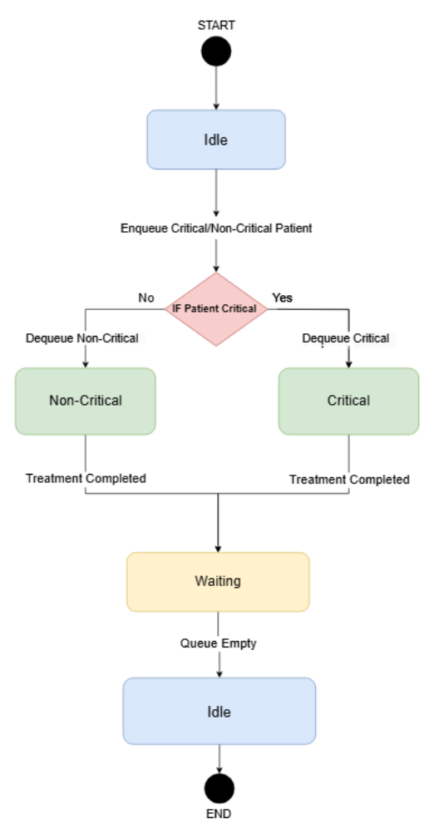

### Explanation of each step

1. **Idle State**:
   * **Status description**: The system starts at rest when the queue is empty. In this case, the emergency room system is waiting for patients to arrive. There are no patients currently being treated and the queue is empty. This is the default state when there are no operations to be performed. The system remains in this state until a new patient arrives.
2. **Transition from Idle to Waiting**:
   * **Trigger**: When a patient arrives, whether critical or not, the system goes from an inactive state to a standby state. This transition occurs because the patient's arrival means that the queue is no longer empty.
   * **Action**: The patient is added to the queue. If the patient is in critical condition, they are placed at the front of the queue for immediate treatment. This procedure ensures that the most urgent cases are dealt with first. This transition ensures that the system is ready to deal with incoming patients and transfer them to the appropriate state based on their condition.
3. **حالة الانتظار (If Patient Critical State)**:
   * **State Description**: This status indicates that the queue contains patients waiting for treatment. Now, the system actively manages the patient queue, and determines who should then be treated based on priority. The queue can contain a mix of critically ill and non-critically ill patients.
   * **Transition**: The system can transition to a critical or non-critical condition based on the priority of the next patient to be treated. This procedure ensures that the system is always ready to handle the next patient in line, whether they are in critical condition or not.
4. **Transition from Waiting to Critical**:
   * **Trigger**: When a critically ill patient is discharged for treatment, the system goes from a standby to a critical state. This transition occurs because the emergency patient needs immediate attention.
   * **Action**: The critically ill patient is removed from the queue and undergoes treatment immediately. This procedure ensures that the most urgent cases are dealt with first, prioritizing the patient's health and safety. This transition demonstrates the system's ability to deal with emergencies effectively.
5. **Critical State**:
   * **State Description**: This represents the treatment of a patient in a critical emergency. During this case, the system focuses on providing the necessary medical care to the patient in critical condition. All resources are directed towards stabilizing and treating the patient's condition.
   * **Transition**: After treating the critically ill patient, the system checks if there are more patients in line. If there are other patients, the system returns to a standby state to deal with the next patient. This procedure ensures a continuous flow of patient management.
6. **Transition from Critical to Waiting**:
   * **Trigger**: After the critical patient is treated, the system needs to determine the next step.
   * **Action**: The system goes back into a standby state to handle the next patient in the queue. This transition ensures that the system is always ready to deal with the next patient, keeping the work running efficiently.
7. **Transition from Waiting to Non-Critical**:
   * **Trigger**: When a non-critical patient is discharged for treatment and there are no critically ill patients, the system goes from waiting to non-critical state.
   * **Action**: A non-critical patient is removed from the queue and undergoes treatment. This procedure ensures that all patients are treated, no matter how severe their condition is. This transition demonstrates the system's ability to effectively manage different emergency levels.
8. **Non-Critical State**:
   * **State Description**: This condition represents the treatment of a patient in a non-critical condition. During this case, the system focuses on providing the necessary medical care to the non-critical patient. Although there is less urgency, it is important to manage these cases efficiently.
   * **Transition**: After treating the non-critical patient, the system checks if there are more patients in line. If there are other patients, the system returns to a standby state to deal with the next patient. This procedure ensures a continuous flow of patient management.
9. **Transition from Non-Critical to Waiting**:
   * **Trigger**: After the patient's noncritical treatment is completed, the system needs to determine the next step.
   * **Action**: The system goes back into a standby state to deal with the next patient in the queue. This transition ensures that the system is always ready to deal with the next patient, keeping the work running efficiently
10. **Transition from Waiting to Idle**:
    * **Trigger**: When the queue is empty after treating all patients, the system goes from a standby to an inactive state. This transition occurs because the system no longer has patients to deal with.
    * **Action**: The system returns to a dormant state, waiting for new patients to arrive. This transition demonstrates the system's ability to reset and prepare for the next set of operations, ensuring it is always ready to efficiently manage the next emergency.

**This case machine diagram ensures an efficient and fair patient management system in the emergency room. By prioritizing critical emergencies while maintaining an orderly process for non-critical cases, the emergency room can handle various patient cases effectively. This approach balances the urgency of treatment with the need to systematically manage a large number of patients.**

**7-Would stack be appropriate in the above case? Explain the abstract data type (ADT) of stack, explaining its main operations and behavior.**

**Queue menu and suitability for emergency system**

**What is a Queue menu?**

A queue is a linear data structure that follows the principle of "first in, first out" (FIFO). In the Queue menu, items from one end, called the background, are added and removed from the other end, called foreground. This means that the first item added to the queue list will be the first item to be removed, just like the queue list or the realistic line. The queue menu supports effective insertions and deletions, making it a convenient option for managing tasks where order matters.

**How a Queue can help with an emergency system**

In the context of an emergency room (ER) system, the Queue is particularly useful for handling patient requests. Patients arrive at different times and should be cared for in the order of their arrival. Using the queue menu ensures that each patient is treated fairly and in the sequence they have reached. This is critical in maintaining an orderly and efficient flow of patients.

**Benefits of using the Queue menu in the electronic reporting system:**

**Justice:** Ensure that patients are cared for in the order they arrived, preventing any patient from being overlooked or skipped.

**Efficiency:** By managing patients by FIFO, the system can handle patient flow quickly and predictably, ensuring that the next patient is always ready to be cared for.

**Simplicity:** The queue structure is simple and intuitive, making it easy to implement and manage within an ER system.

**Predictability:** A queue provides a clear and predictable order of service, helping to effectively manage patient expectations and resource scheduling.

**شرح عمليات tail**

**Enqueue:** Add a patient to the end of the queue list. This process ensures that new patients join the line behind existing patients, while maintaining the order of arrival.

**Dequeue:** Remove a patient from the front of the queue list. This process ensures that the patient who has waited longer is the next to be treated.

**getFirst:** Retrieve the patient at the top of the queue list without removing it. This helps determine the next patient to be served without changing the queue menu.

**getLast :** Retrieve the patient at the end of the queue list without removing it. Useful for administrative purposes, such as checking the length of the queue list.

**isEmpty (check if the queue list is empty):** Check if the queue list contains any patients. This is useful for determining if there are patients waiting to be cared for.

**Stack and its unsuitability for emergency system**

**What is stack?**

stack is a linear data structure that follows the Last In First Out (LIFO) principle. In stack, elements are added and removed from the same end, known as the top. This means that the last element added to the stack will be the first element to be removed. Piles are often compared to a group of boards: they add and remove boards from above.

**Why is stack not suitable for an emergency system?**

In the context of an ER system, using stack may be inappropriate because it works on a LIFO basis. This means that the newly added patient will be the first to be cared for, which is unfair and ineffective for the emergency room as patients must be treated in the order they arrived. Using stack may disrupt the service arrangement and may result in significant delays for patients who arrive early.

**Explanation of stack operations**

**1. Push:**

• **Description**: Adds an item to the top of the stack.

• **Process**: Push (element)

• **Effect**: The item is added to the top of the stack.

**2. Pop:**

• **Description**: Remove the item from the top of the stack.

• **Process**: POP

• **Effect**: The top element is removed from the stack. If the stack is not empty, it returns the deleted element; otherwise, it may indicate override.

**3. Peek**:

• **Description**: Returns the item on top of the stack without removing it.

• **Process**: Peek

• **Effect**: Returns the element on top of the stack without modifying the stack. If the stack is empty, it may indicate a flow overflow.

4. **isEmpty**:

• **Description**: Checks if stack is empty.

• **Operation**: isEmpty()

• **Impact**: Returns true if stack is empty; otherwise, it returns false.

**5. Size:**

• **Description:** Returns the number of items in the stack.

• **Operation:** size ()

• **Effect:** Returns the number of items currently in stack.

**Abstract Data Type (ADT)**

### Types of abstract data (ADTs) and their role in organizing and managing the complexity of data structures

Abstract Data Types (ADTs) play a vital role in organizing and managing the complexity of data structures through the concept of encapsulation. In ADTs, encapsulation involves the aggregation of both data and the methods that work on that data into a single unit. This aggregation makes it easy to clearly organize the structure, enhancing code modular and maintainability. For example, stack ADT encapsulates not only the elements it contains, but also methods like push and pop to handle stack. Encapsulating both data and processes contributes to ADTs In a structured and understandable approach to dealing with complex data structures.

#### **The Importance of ADTs Operations**

ADTs are defined by a set of operations that encapsulate their primary function. These operations represent the basic actions that users can perform on data encapsulated by ADT. By creating a consistent interface, processes remove complex executable details, allowing users to interact with ADT based on functions rather than internal mechanisms. This abstraction enhances ease of use and simplifies the learning curve for users, creating a unified way to work with data structure. Processes within ADTs act as a bridge between users and underlying data, emphasizing what actions are possible without going into how these actions are achieved.

#### **Flexibility in ADTs operations**

ADT operations provide not only basic functionality but also inventory changes in data state. Operations can be designed to modify the internal state of ADT (variable operations) or recreate a new copy without modifying the existing entity (static operations). This flexibility allows ADTs to meet the requirements of different applications, providing options for diverse usage scenarios. In addition, ADT operations includeError handling mechanisms, which determine the expected behavior in the presence of errors and contribute to the overall robustness of the data structure.

#### **Operational efficiency in the design of ADTs**

Operational efficiency is a critical consideration in the design of ADTs. Choices made during design, such as the time complexity of operations, directly affect the performance of the data structure. A balance between ease of use and operational efficiency is essential to creating a comprehensive and effective ADT. In addition, ADT operations must be designed with compatibility in mind, ensuring seamless integration with other components of the system. Proper documentation, which outlines the purpose, expected behavior, and contracts for each operation, helps users in the correct use of ADT. Finally, a focus on scaling, testing, and validation contributes to the reliability and adaptability of ADTs in diverse software applications.

#### **Pluralism in ADTs**

Multiplicity, a key concept in object-oriented programming, is embodied in ADTs through the ability to interchangeably use different implementations. This flexibility allows developers to switch between multiple ADT implementations without affecting the external code that uses ADT. Multiplicity promotes code reuse, modular and adaptability, making ADTs versatile components in software design.

#### **Heredity in ADTs**

The concept of inheritance complements ADTs by allowing the creation of specialized ADTs based on existing ones. Inheritance enables the expansion of functions while retaining the core attributes and operations of the original ADT. For example, a specialized ADT queue with additional features can inherit from the underlying ADT queue, promoting code reuse and maintaining the hierarchical structure. This hierarchical organization promotes clarity and diversity of relationships between different ADTs .

#### **Packaging at the architectural level**

The concept of encapsulation extends beyond individual ADTs to the broader architectural level, promoting the aggregation of multiple ADTs into a cohesive unit or package of structured and ideal code base. Architectural-level encapsulation involves grouping relevant ADTs, avoiding internal complexities, and providing a well-defined interface. This practice promotes code organization, reduces dependency, and facilitates a modular approach to software development.

#### **Synchronization and parallelism in ADTs**

Synchronization and parallelism considerations are an integral part of modern software systems, and ADTs play a role in addressing these challenges. Concurrent data structures, encapsulating synchronization mechanisms and secure multi-line operations, allow developers to design scalable, multi-line-friendly applications. By encapsulating synchronization concerns within ADTs, developers can abstract the complexities of shared resource management and concurrency, enhancing maintainability and accuracy in concurrent systems.

Queue **and Stack**  Menu Comparison Table

|  |  |  |
| --- | --- | --- |
| Feature | Queue | Stack |
| Principle | **Follows FIFO , ensures that the first added item is the first to be removed** | **Following LIFO, ensures that the last element added is the first to be removed** |
| Main operations | **Enqueue, Dequeue, getFirst, getLast, isEmpty** | **Push, Pop, Peek, Size, isEmpty, Stack** |
| Use case | **Best for scenarios where tasks must be processed in the order they arrive** | **Best for scenarios where recent tasks must be tackled first** |
| Emergency Room Suitability (ER) | **Ideal for the emergency room where patients are kept in order and ensure fair treatment** | **Not suitable for emergency room where it will disrupt service arrangement** |
| Justice | **Ensures justice by processing items in the order they arrive** | **Does not guarantee justice as it prioritizes recently added elements** |
| Efficiency | **Effective for tasks that require sequential processing and manage tasks in order** | **Effective for reversing processes and managing tasks that require the latter to be processed first** |
| Simplicity | **Simple in implementation and management, especially suitable for real-time systems such as emergency room** | **Simple to implement but not suitable for tasks that require arrangement such as managing patients in the emergency room** |

### The best option for emergency room system: (Queue)

In the context of an emergency room system, Queue is undoubtedly the best option for managing patient requests. FIFO's queue principle ensures that patients are treated in the order of their arrival, which is vital for justice and efficiency in an emergency environment. With Queue, the system can manage patient flow predictably and effectively, ensuring that every patient receives fair and timely treatment.

On the other hand, a stack that operates on the principle of LIFO would be highly inappropriate for this scenario. Using Stack means that the newly added patient will be the first to be served, resulting in unfair treatment and significant delays for patients who arrived earlier. This will disrupt the service arrangement and can lead to critical efficiencies and potentially life-threatening delays in patient care.

While both Stack and Queue are useful as a data structure, their relevance depends on the task-specific requirements. For an emergency room system, where the order of arrival of patients is the most important, Queue is the perfect choice. Its ability to manage patient flow fairly and effectively makes it indispensable for maintaining the high standards of care and service expected in an emergency room environment.

**Component 2: Medical Information System**

**1. There is a need in the hospital to develop a unit that helps doctors predict how many days each patient needs to stop taking the antibiotic. Usually, doctors calculate the number by taking the antibiotic dose into account and how it gradually kills the bacteria. If we say that a patient has been prescribed an antibiotic at a dose of 700 mg, and every day the patient must reduce the dose by 35% from the original dose, we can create the iterative recall of this unit as follows: return 1 + calculateDays(newDose - 0.35 * 700).**

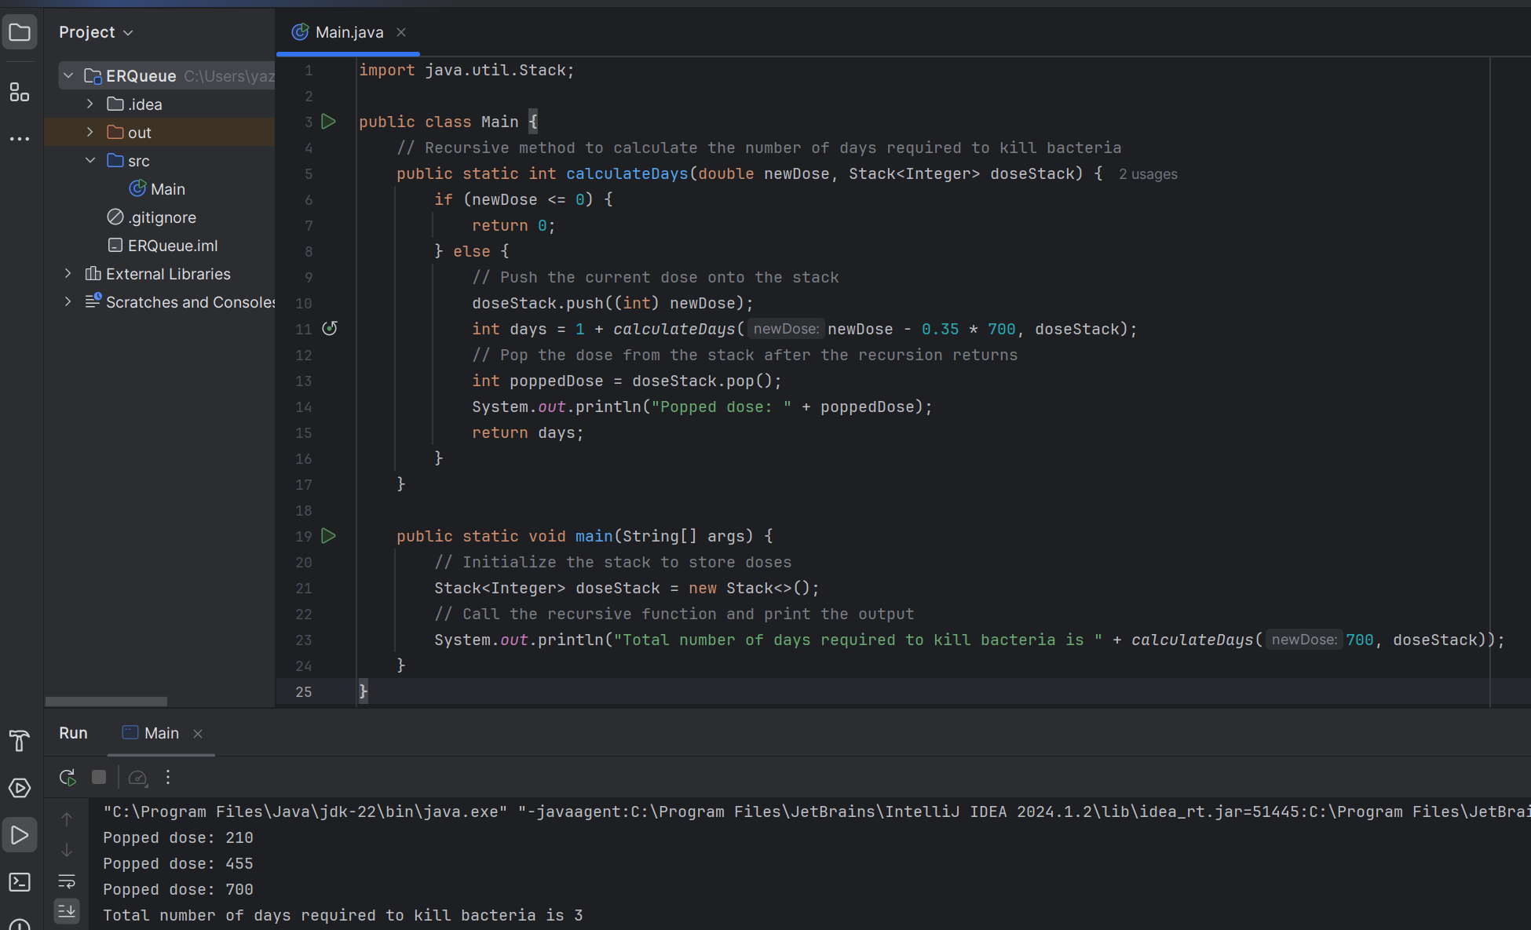

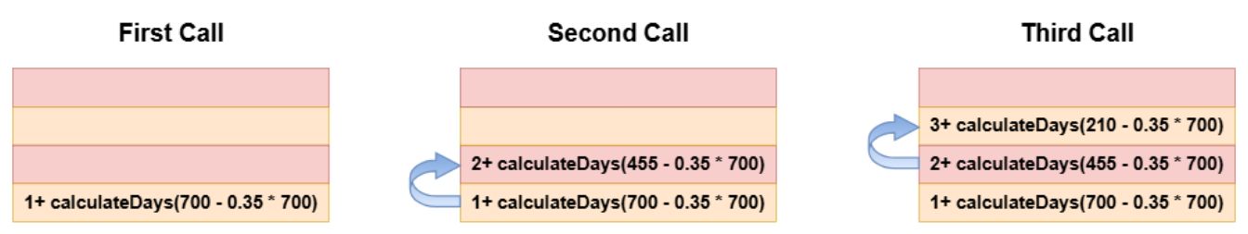

**Recursive Calls Diagram**

The graph shows the process of calculating the number of days it takes for a patient to stop taking the antibiotic, starting with an initial dose of 700 mg and reducing the dose by 35% from the original dose each day. This is represented by a series of repeated calls to **the CalculDays** function.

**Problem context**

The hospital needs a unit to help doctors predict how many days a patient needs to stop taking the antibiotic. The calculation takes into account the initial dose and the daily reduction of the dose by 35%. The countDays recursion function **is** a model for this reduction.

**Recursive Function Definition**

**public static int calculateDays(double newDose) {**

**if (newDose <= 0) {**

**return 0;**

**} else {**

**return 1 + calculateDays(newDose - 0.35 * 700);**

**}**

**}**

Thus at the time of the third execution, the value of newDose -35 becomes < 0 and the prerequisite will be evaluated and 3 will be returned by functionCalculDays().

function1 returns +calculateDays(newDose - 0.35 * 700), signals that another day of reduction has passed, and functionalizes itself at the reduced dose.

**Explain how the stack handles iterative calls to such functions in computer memory, and explain how stack operations behave in this case.**

### Analyze how Stacks handle Recursive Calls in computer memory

Recursive Calls is a common technique in programming where a function calls itself to solve a smaller problem of the same type. To manage these Recursive Calls, your computer uses a data structure called Stack. Here's a detailed breakdown of how Stacks handle these calls in memory.

#### **إطار نداء (Function Call Stack Frame)**

When a function is called, a Stack window is created for that function. This window contains all the information needed to execute the function correctly:

* **Parameters**: The arguments passed to the function.
* **Local variables**: Variables declared within the function.
* **Return Address**: The point in the program to which the function must return after execution is completed.

Each function call, including Recursive Calls, produces a new Stack frame that is pushed into the Call Stack.

#### **نمو الـ Stack مع Recursive Calls**

When an iterative function is called, a new Stack frame is added to the top of the stack. This means that the most modern function call is always at the top. For example:

1. **First call**: calculateDays(700)
   * The Stack frame for this appeal is created with parameter 700.
2. **First Iterative Call**: calculateDays(455)
   * A new Stack frame is created for this call with parameter 455 and pushed to the Stack.
3. **Second Iteration**: calculateDays(210)
   * Another Stack frame with parameter 210 is added to the top of the Stack.

This process continues, with a new frame added for each iterative call to the Stack.

#### **Foundation status and removal of frames from the stack**

Recursive Calls persist until you reach the Base Case. In our example, the base case is when newDose is less than or equal to 0. On this point:

* Returns a function value (for example, 0), and the current stack frame is removed.
* Control reverts to the previous function call, which continues to execute and finally returns, removing its frame from the stack.

This process of returning and removing Stack frames is called Stack Unwinding. This process continues until all Recursive Calls return and the first call ends.

#### **Behavior of stack operations**

1. **Push Operation**:
   * Each function call (including Recursive Calls) triggers a push, adding a new Stack frame to the top of the Stack. This window contains all the necessary implementation details such as parameters, local variables, and return address.
2. **Pop Operation**:
   * When the function is complete, the removal process removes the Stack frame from the top of the stack. Control reverts to the function that called the current function, which resumes execution from point after the function call.

#### **Risks and considerations**

* **Stack Overflow**:
  + If the iterations don't reach the baseline state, the stack can be quickly exhausted, resulting in the Stack Overflow. This happens because each iterative call adds a new frame, consuming memory until it runs out.
* **Memory Resources**:
  + To execute the instructions, the program requires memory resources. Each Stack frame uses memory, so deep redundancy can consume significant memory, affecting system performance.

### Why use Stack and not Queue

#### **Stack Features (LIFO)**

1. **ترتيب التنفيذ (Order of Execution)**:
   * Stacks follow another principle inside, first out (LIFO). The most recent function call is the first in completeness. This order is necessary for iteration because each iterative call must be completed before the function that called the call continues.
2. **Memory Efficiency**:
   * Stacks efficiently manage memory for function calls. Each caller has an isolated space, and this space is freed when the function is completed, ensuring that memory is used in an orderly manner.
3. **Correct Return Order**:
   * Using the stack ensures that returns to functions occur in the correct order. The function that was finally called must first return to resume execution correctly at the return address.

#### **Queue Properties (FIFO)**

1. **ترتيب التنفيذ (Order of Execution)**:
   * Queues follow the principle of first in, first out (FIFO), which means that the first function call is first in completion. This is not suitable for repetition as it will disrupt the order necessary for correct execution.
2. **عدم الكفاءة لنداءات functions (Inefficiency for Function Calls)**:
   * Using Queue for function calls means waiting until all previous calls are complete, leading to incorrect behavior and the possibility of infinite loops in iterative functions.
3. **Incorrect Return Order**:
   * The queue will return functions in the order in which they are called, not in the order in which they are completed. This disrupts the necessary execution flow and can corrupt the state of the program.

### Why we should use Stack

1. **حفظ سياق التنفيذ (Preservation of Execution Context)**:
   * Stacks save the execution context for each function call, including local variables and return addresses. This preservation is necessary for the correct execution of iterative functions.
2. **الحفاظ على ترتيب التنفيذ الصحيح (Maintaining Correct Execution Order)**:
   * The LIFO principle in Stacks ensures that the most recent iterative function call is first in completion, maintaining the correct execution flow and return order.
3. **Efficient Memory Management**:
   * Stacks provide an organized and efficient way to manage memory for function calls. Each function call gets its own space, which is automatically released after the function is completed.
4. **آلية مدمجة (Built-in Mechanism)**:
   * Most programming languages support built-in stacks to handle functions and repetition calls. This built-in mechanism optimizes performance and reliability, making Stacks the ideal choice for managing iterative functions calls.

**Stacks are the preferred data structure for handling iterative functions calls due to their LIFO nature, which is perfectly aligned with the need to complete the latest function call first. Stacks save execution context, ensure the correct execution order, and manage memory efficiently. On the other hand, using Queue will disrupt the order of execution and lead to incorrect behavior, making it unsuitable for handling iterative functions calls. .**

**2. The information of each patient is stored in the hospital database, and doctors retrieve this data for their studies and discussions. Sometimes, doctors ask for an ordered patient list, so there is a need to implement a triage algorithm based on the characteristics of doctors.**

**Distinguish between Selection Sort and Quick Sort performance, and draw conclusions to decide which algorithms perform best. Fill in this table and answer the following questions.**

**Implement the Quick Sort and Selection Sort algorithms and test them on 4 arrays containing the following:**

1- Array 1 has sorted numbers ترتيب تصاعدي

Example: 1 | 2 | 3 | 4 | 5 | 6 | 7 | 8 | 9 | 10

2- Array 2 is reversely sorted ترتيب تنازلي

Example: 10 | 9 | 8 | 7 | 6 | 5 | 4 | 3 | 2 | 1

3- Array 3 is filled with random numbers ارقام عشوائية

Example: 5 | 2 | 7 | 4 | 8 | 10 | 9 | 1 | 3 |6

4- Array 4 is partially sorted ترتيب جزئي

Example: 1 | 2 | 3 | 5 | 6 | 4 | 7 | 8 | 10 | 9

**CODE:**

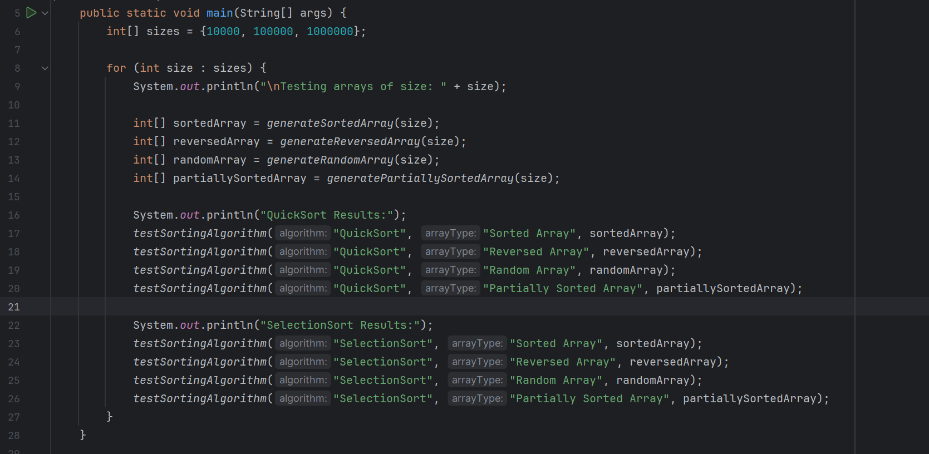

**Clarification:**

This is the entry point of the program.

It specifies matrix sizes containing different test sizes (10,000, 100,000, and 1,000,000).

For each volume, it creates four types of matrices: ordered, reversed, random, and partially ordered.

It tests both the QuickSort andSelectionSort algorithms on each type of array, and measures and prints the time it takes to sort each array.

**Clarification:**

It takes the name of the sorting algorithm, the type of array (for registration), and the matrix to be sorted.

Reproduces the array to avoid modifying the original.

Records the start time, executes the sorting algorithm based on the selected type, and then records the end time.

Prints the time it takes to sort the array.

**Clarification:**

Creates an ordered array of the specified size.

Each item is sequentially incremented by 1 starting from 1.

**Clarification:**

Creates an inverse array with the specified size.

Each element is sequentially reduced by 1 starting from the size of the matrix.

**Clarification:**

Generates a random set of the specified size.

Each element is a random integer between 1 and the size of the matrix.

**Clarification:**

Creates a partially sorted array of the specified size.

The first half of the matrix is sorted sequentially, and the second half contains random integers.

**Clarification:**

Sort the array repeatedly using the QuickSort algorithm.

The medianOfThreePartition method is used to split the array and determine the axis.

**Clarification:**

Using the median method, the axis chooses from among the three to reduce the chances of worse performance.

Swap items to put the average of the first, middle and last items as a pivot.

**Clarification:**

Dividing the matrix around the axis.

Items lower than the axis are placed on the left, and items larger than the axis are placed on the right.

**Clarification:**

Swap elements in indices i and j in the array.

**Clarification:**

Implements the SelectionSort algorithm.

Finds the minimum number of elements in the unsorted part of the array and replaces it with the first unsorted element.

**Clarification:**

Swap elements in indices i and j in the array.

* Each method is designed to perform a specific task, contributing to the overall function of sorting and testing the performance of different sorting algorithms on different types of arrays.

**RUN CODE:**

**INPUT 10000**

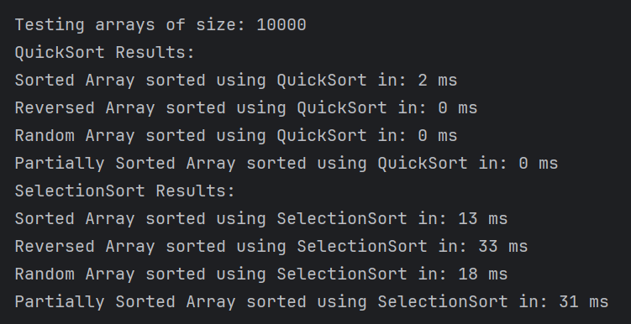

**INPUT 100000**

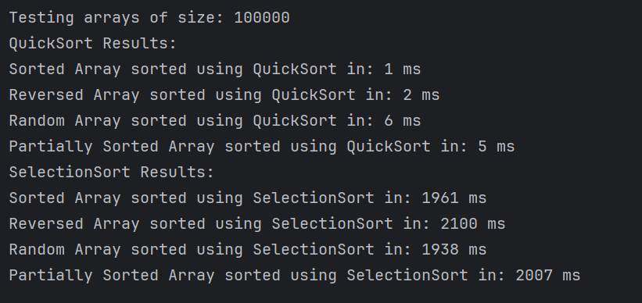

**INPUT 1000000**

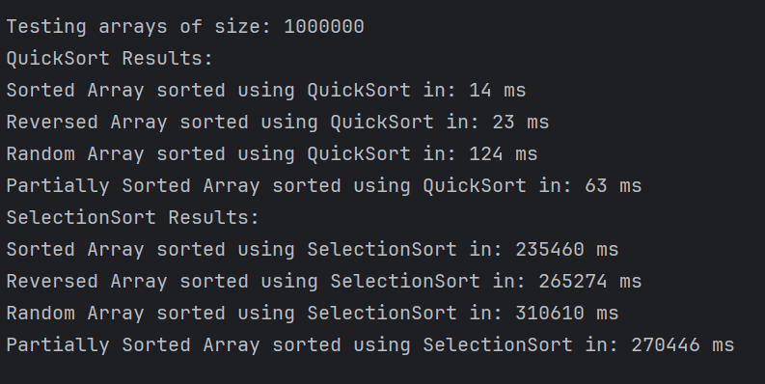

**Test the algorithms on these four arrays, considering three input sizes: 10,000, 100,000, and 1,000,000. Use a method to calculate the algorithm's uptime, and then fill in the following table:**

|  |  |  |  |  |  |
| --- | --- | --- | --- | --- | --- |
| **Sorting Algorithm** | **Input Size** | **Sorted** | **Reversed** | **Random** | **Partially Sorted** |
| **Selection Sort** | **N = 10,000** | 13ms | 33ms | 18ms | 31ms |
| **N = 100,000** | 1961ms | 2100ms | 1938ms | 2007ms |
| **N = 1000,000** | 235460ms | 265274ms | 310610ms | 270446ms |
| **Quick Sort** | **N = 10,000** | 2ms | 1ms | 0ms | 0ms |
| **N = 100,000** | 1ms | 2ms | 6ms | 5ms |
| **N = 1000,000** | 14ms | 23ms | 124ms | 63ms |

**2.1 What is the complexity of each algorithm?**

|  |  |  |  |
| --- | --- | --- | --- |
| **Sorting Algorithm** | **Best Case** | **Worst Case** | **Average Case** |
| **Quick**  **Sort** | O(n log n) | O(n2) | O(n log n) |
| **Selection**  **Sort** | O(n2) | O(n2) | O(n2) |

**2.2 Which algorithms performed better.**

When comparing the performance of the Selection Sort algorithm and the Quick Sort algorithm, several factors must be considered, including time complexity, space complexity, and the nature of the dataset. Below, we will provide a detailed analysis of both algorithms, highlighting the strengths and weaknesses through explanation, comparison, and a summary table.

#### **Selection Sort**

**Time complexity:**

* **أفضل حالة (Best Case)**: O(N^2)
* **Average Case**: O(N^2)
* **أسوأ حالة (Worst Case)**: O(N^2)

**Complexity of space:**

* **In-place Sorting**: Only requires a fixed amount O(1) of additional memory.

Selection Sort is a simple algorithm that repeatedly finds and places the lowest element of the unsorted part. Despite its simplicity, selection sorting is inefficient for large sets of data due to the complexity of its O(N^2) time in all cases. This low efficiency arises because the algorithm does N comparison to each element of N elements, resulting in an N*N = N^2 operation.

**Benefits:**

1. **Simplicity**: Easy to understand and implement.
2. **Memory Usage (Memory Usage**): Requires a fixed amount of additional memory, making it suitable for systems with limited memory.

**Disadvantages:**

1. **Time Inefficiency**: Not suitable for large sets of data due to the complexity of its time squared.
2. **Performance**: Slow for large or even medium-sized sets of data.

#### **Quick Sort**

**Time complexity:**

* **أفضل حالة (Best Case)**: O(N log N)
* **الحالة المتوسطة (Average Case)**: O(N log N)
* **أسوأ حالة (Worst Case)**: O(N^2)

**Complexity of space:**

* **In-place sorting**: Typically requires O(log N) of additional memory for the recall stack.

**Description:**

#### **Quick Sort** is a highly effective algorithm that uses a divide-and-conquer approach. It works by choosing an axis element (pivot) and dividing the array into smaller parts of the lower and larger elements of the axis. These parts are then sorted repeatedly. The performance of quick sorting is highly dependent on the choice of axis. In the ideal case, the axis divides the array into two equal halves, complicating the time of the best case O(N log N). However, bad axis selection can complicate the time of the worst case O(N^2).

**Benefits:**

1. **Efficiency**: Generally faster than other algorithms with O(N log N) complexity for large data sets.
2. **Divide and Conquer**: Very suitable for parallel processing and can handle large datasets efficiently.
3. **Average Performance**: Usually works well with O(N log N) time complexity.

**Disadvantages:**

1. **Worst-case Performance**: Can deteriorate to O(N^2) if the axis is poorly chosen.
2. **Space Usage (Space Usage**): Requires additional space for the iterative call stack, although it is usually logaritic.

### Comparative Analysis

To determine which algorithm has the best performance, let's compare them based on several criteria:

**1. تعقيد الوقت (Time Complexity):**

* **Selection Sort**: O(N^2) in all cases.
* **Quick Sort**: O(N log N) in optimal and moderate cases, O(N^2) in the worst case.

**2. Space Complexity:**

* **Selection Sort**: O(1) extra space.
* **Quick Sort**: O(log N) is an additional space for the iterative call stack.

**3. Practical Performance:**

* **Selection Sort**: Generally slow for large sets of data.
* **Quick Sort**: Efficient for large sets of data, although performance can be affected by axis selection.

**4. Stability :**

* **Selection Sort**: Unstable (the relative order of equal elements may change).
* **Quick Sort**: Unstable (the relative arrangement of equal elements may change).

**5. البساطة وسهولة التنفيذ (Simplicity and Ease of Implementation):**

* **Selection Sort**: Simple and easy to implement.
* **Quick Sort**: More complicated due to the partitioning process.

### Table Summary

| **Standards** | **Selection Sort** | **Quick Sort** |
| --- | --- | --- |
| **أفضل حالة (Best Case)** | O(N^2) | O(N log N) |
| **Average Case** | O(N^2) | O(N log N) |
| **أسوأ حالة (Worst Case)** | O(N^2) | O(N^2) |
| **Space Complexity** | The(1) | O(log N) |
| **Stability** | No | No |
| **Simplicity** | High | medium |
| **Efficiency** | Low | high |
| **Practical Use** | Small sets of data | Large data sets |

### Which algorithm has better performance?

****Quick Sort**** generally has better performance compared to ****Selection Sort**** for the following reasons:

1. **Time Complexity**: Rapid sorting, with its time complexity in optimal and moderate cases O(N log N), is much more efficient than the time complexity O (N^2) for sorting by choice, especially for large sets of data. This efficiency makes quick sort suitable for practical applications where large amounts of data need to sort quickly.
2. **Practical Efficiency**: In practical scenarios, quick sorting is often faster than other algorithms with O(N log N) complexity due to its good cache performance and splitting efficiency.
3. **Versatility**: Quick sorting can handle large data sets and is adaptable to different data distributions, while choice sorting suffers with anything beyond small or medium sets of data.

#### Although the performance of Quick Sort may deteriorate to O(N^2) in the worst case, this can be mitigated by techniques such as random axis selection or the use of the triple mean of axes, ensuring that quick sort remains robust and effective in most practical scenarios.

While both algorithms have their uses, quick sort stands out as a better option in terms of performance in most sorting tasks, especially when dealing with large datasets. On the other hand, it is preferable to use selection sorting for educational purposes or very small datasets where simplicity is an advantage.

**2.3 How did asymptotic analysis help judge the performance of each algorithm?**

Asymptotic Analysis is a powerful tool that helps evaluate the performance of algorithms by looking at their behavior when the input volume increases. In this context, we will explain how convergent analysis helped us judge the performance of both the Selection Sort algorithm and the Quick Sort algorithm. We will discuss this through detailed explanations, important points, and illustrative examples.

#### **The concept of convergent analysis**

Convergent analysis focuses on how an algorithm behaves when the input volume increases endlessly. This analysis helps to understand the general behavior of the algorithm without the need for precise details about the algorithm's performance for each particular case. The analysis is based on Time Complexity and Space Complexity and uses mathematical expressions to illustrate performance such as O(N), O(N log N), O(N^2), and others.

#### **How to judge the performance of algorithms using converged analysis**

1. **تعقيد الوقت (Time Complexity)**:
   * ****Selection Sort****: The complexity of the time to sort by choice is O(N^2) in all cases. This means that the performance of the algorithm increases squarely as the input volume increases. Even with a small increase in input volume, this complexity can lead to a significant increase in execution time.
   * ****Quick Sort****: The time complexity for quick sort is O(N log N) in the intermediate case and best case, and O(N^2) in the worst case. This means that quick sort is generally more efficient, with execution time increasing much more slowly with increased input size compared to sorting by choice.
2. **Space Complexity**:
   * ****Selection Sort****: The complexity of the space for sorting by choice is O(1), which means that it requires a constant amount of additional memory regardless of the input size. This makes it suitable for systems with limited memory.
   * ****Quick Sort****: The space complexity for quick sort is O(log N) for the stack. Although it requires additional stack space, this complexity is still acceptable in most practical scenarios.

### Key points of performance analysis using converged analysis

1. **Best Case Complexity**:
   * Convergent analysis helps us understand how the algorithm behaves in ideal scenarios. For quick sorting, complexity is at best O(N log N), which means very fast performance when balanced divisions exist.
2. **Worst Case Complexity**:
   * Convergent analysis helps us identify scenarios in which the algorithm may deteriorate. For quick sort, performance can deteriorate to O(N^2) when inappropriate axes are repeatedly selected.
3. **Average Case Complexity**:
   * Convergent analysis provides a clear picture of the overall performance of the algorithm in most cases. For rapid sorting, the complexity in the intermediate cases is O(N log N), which makes it generally more efficient compared to selection sorting, whose complexity remains O(N^2) in all cases.
4. **Space Complexity Comparison**:
   * Convergent analysis allows us to compare the amount of memory required by algorithms. Although fast sorting requires additional memory for the stack, this complexity is logarithmic, which is acceptable in most practical cases, compared to the fixed space complexity of sorting by choice.

### Detailed explanation of each point

#### تعقيد الوقت (Time Complexity)

* ****Selection Sort**:**
  + In all cases, sorting by choice must find the item below the unsorted part and swap it with the first item. This process takes O(N) operations each time, and N repeats once, resulting in a time complexity of O(N^2). This means that even in the best cases, where the elements are already in a certain order, the algorithm will still do the same number of comparisons and transitions.
* ****Quick Sort**:**
  + In the best case, quick sort chooses axes that divide the array into approximately equal halves, resulting in a time complexity of O(N log N). However, in the worst case, such as consistently choosing the worst axis, performance can deteriorate to O(N^2). The complexity of time in intermediate cases is still much better than sorting by choice, making it generally more efficient.

#### Space Complexity

* ****Selection Sort**:**
  + Sort by choice requires additional static memory O(1), because sorting is done in place without the need for additional data structures.
* ****Quick Sort**:**
  + Quick sort requires extra space for the O (log N) stack. However, this complexity remains relatively low compared to the significant advantages in sorting speed.

### Comparison and summary table

| **Standards** | **Selection Sort** | **Quick Sort** |
| --- | --- | --- |
| **أفضل حالة (Best Case)** | O(N^2) | O(N log N) |
| **Average Case** | O(N^2) | O(N log N) |
| **أسوأ حالة (Worst Case)** | O(N^2) | O(N^2) |
| **Space Complexity** | The(1) | O(log N) |
| **Stability** | No | No |
| **Simplicity** | High | medium |
| **Efficiency** | Low | high |

### Conclusion

Convergent analysis helps us judge the performance of algorithms by providing a clear picture of how the algorithm behaves as the input volume increases. Quick sort stands out as a better option in terms of performance in most tasks, especially when dealing with large datasets, due to its time complexity in the average case and the best cases O(N log N). Although sorting by choice is simple and requires a fixed space, its time complexity O(N^2) makes it unsuitable for large sets of data.

### 2.4 Identify two methods for measuring the efficiency of an algorithm

Measuring the efficiency of an algorithm is critical to understanding its performance and suitability for different applications. There are several ways to assess the efficiency of an algorithm, but two main methods stand out in particular: Time Complexity and Space Complexity. Below, we'll discuss these two methods in detail and use examples from the sort, Selection Sort and Quick Sort algorithms to illustrate how to apply them.

### Method One: Time Complexity

**Definition**: Time complexity measures the amount of time it takes an algorithm to complete its work as a function of the length of inputs. It is expressed using Big O notation, which classifies algorithms according to their growth rates as the input volume increases.

**Why time complexity is important**:

* **Performance**: Time complexity provides insight into the expected performance of the algorithm, especially with large inputs.
* **Scalability**: Helps predict how the algorithm expands as input volume grows.
* **Comparison**: It allows comparing different algorithms based on their efficiency.

**Example of Selection Sort**:

* **Best Case**: O(N^2) – Even if the array is already ordered, sorting by choice continues to check each element to find the smallest.
* **Intermediate state**: O(N^2) – The algorithm makes N/2 comparisons on average for each of the N elements.
* **Worst case**: O(N^2) – The number of comparisons and permutations remains quadratic regardless of the order of the elements.

**Example of Quick Sort**:

* **Best case**: O(N log N) – When the axis splits the array into two roughly equal halves, the algorithm works efficiently.
* **Intermediate state**: O(N log N) – On average, quick sort handles data efficiently thanks to balanced partitioning.
* **Worst case**: O(N^2) – This occurs when constantly choosing the axis leads to substantially unbalanced divisions, such as always choosing the smallest or largest element.

### Method Two: Space Complexity

**Definition**: Space complexity measures how much memory an algorithm needs to run as a function of the length of inputs. This includes the space required for the input itself and any additional space required during implementation.

**Why the complexity of the space is important**:

* **Resource usage**: Helps determine how much memory the algorithm requires, which is vital in environments with limited memory.
* **Efficiency**: An algorithm that uses less memory can be more efficient and practical for large sets of data.
* **Scalability**: Understanding space requirements ensures that the algorithm can handle large inputs without running out of memory.

**Example of Selection Sort**:

* **Area complexity**: O(1) – Sort by choice is an in-place sorting algorithm, which means that it requires a fixed amount of additional space regardless of the size of the input. It only uses some additional variables to track the lower element and toggle values.

**Example of Quick Sort**:

* **Space complexity**: O(log N) – Quick sort requires additional space for the iteration stack. In the best and intermediate cases, the depth of the iteration tree is log N, which complicates the logarithmic space. However, in the worst case, the depth can be N, resulting in linear space complexity.

### Comparative Analysis

#### تعقيد الوقت (Time Complexity)

* ****Selection Sort**:**
  + **Best Condition**: O(N^2)
  + **Intermediate state**: O(N^2)
  + **Worst case**: O(N^2)
  + **Performance**: Poor for large data sets due to quadratic growth.
* ****Quick Sort**:**
  + **أفضل حالة**: O(N log N)
  + **Intermediate State**: O(N log N)
  + **Worst case**: O(N^2)
  + **Performance**: Generally efficient for large sets of data with balanced partitioning.

#### Space Complexity

* ****Selection Sort**:**
  + **Area complexity**: O(1)
  + **Memory usage**: The minimum amount of additional memory required, making it suitable for environments with limited memory.
* ****Quick Sort**:**
  + **Area** complexity: O(log N) in the intermediate case.
  + **Memory usage**: Requires extra space for the iteration stack, but this is usually acceptable and faster than it's fast.

### Evaluation of algorithms

**Competency considerations**:

1. **Time complexity**:
   * **Selection Sort**: Not suitable for large data sets due to its O(N^2) complexity, resulting in long execution times.
   * **Quick Sort**: Usually more efficient for large sets of data, with medium complexity O(N log N), but be careful to avoid the worst cases.
2. **Complexity of space**:
   * **Selection Sort**: Excellent in terms of memory efficiency with fixed space requirements.
   * **Quick Sort**: More efficient in using space compared to other iterative algorithms thanks to its logarithmic complexity in space, but can degenerate into linear complexity in the worst case.

By analyzing both time complexity and space complexity, we gain a thorough understanding of the efficiency of the algorithm. Time complexity provides insight into how quickly the algorithm processes inputs of different sizes, while space complexity tells us about memory requirements. Using these two methods to evaluate sorting by selection and quick sort, we see that quick sort generally provides better performance for large sets of data thanks to its faster time complexity in the average case. However, the minimum space requirements for sorting by choice make it a practical choice in scenarios With limited memory. Understanding these exchanges helps in choosing the most appropriate algorithm for a particular application.

**3. The hospital building is huge and consists of many floors and rooms. Every day, treating physicians make daily rounds of patients to get updates on their condition. Consider the following chart of hospital rooms and the distance between them.**

**The doctor's tour should be well organized to save time. Investigate (track) apply the Dijkstra and Bellmanford algorithms for shorter routes from one location to another to visit all rooms A to K, and view all the details of tracking the algorithms on the chart above. Considering that the distance between each room (paragraph) and another is measured in meters. Draw the shortest path between A and K.**

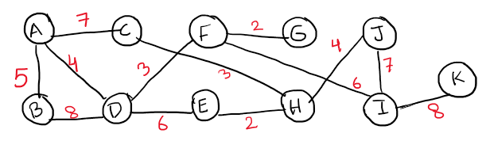

**Solution:**

**Explanation of the solution of the Dijkstra algorithm**

The Dijkstra algorithm is a classic method used to find the shortest paths from the source top to all other peaks in a weighted graph. Below, I will explain how to apply the algorithm to the graph provided to determine the shortest path from node A to node K. The explanation will include details of each step, the status of the distance table, and the reason behind the path chosen.

**Graph and distance table explanation**

**Chart representation:**

The graph provided shows nodes A to K with weighted edges representing the distances between them. The goal is to determine the shortest path from node A to node K.

**Initial preparation:**

Start from node A, initializing space to A as 0 and all other nodes as infinity.

* + 1. Rating neighbors A: B (5), C (7), D (4).

Update previous spaces and nodes.

**Navigate to the node with the smallest temporary distance, which is (A4) D.**

Update previous spaces and nodes.

**Moved to F, and then update the tracks through F: (7D).**

Update previous spaces and nodes.

**Moved to H, and then update the tracks through I: (13F).**

Update previous spaces and nodes.

**Finally, go to I, and then update the routes through K: (21I).**

**1- Review the advantages of encapsulation in object-oriented programming for abstraction.**

**Packaging history**

In the world of computer science, a new programming paradigm began to take shape during the transformative era of the sixties and seventies. It was a time when software systems became increasingly complex, and the need for a more effective way to design, manage, and maintain these systems became apparent.

In this evolving landscape, a programming language called Simula emerged as a pioneer. Simola was developed in the sixties of the twentieth century, introducing pioneering concepts of classes and objects, and laying the foundation for what would later be known as object-oriented programming (OOP). Simula' s innovative ideas provided a way to represent real-world entities as objects in the digital world.

As the journey continued into the seventies, a language called Smalltalk entered the theater, expanding on the ideas presented by Simula. Smalltalk became one of the first true object-oriented programming languages, promoting encapsulation, inheritance, and polymorphism.

In the midst of this transformative period, visionary computer scientist Alan Kay and his team at Xerox PARC (Palo Alto Incorporated Research Center) have been at the forefront of shaping the future of software development. Alan Kay envisions a world in which the program simulates real-world entities through the use of objects and messages.

The concept of packaging began to emerge as a basic principle of OOP during this time. The idea was simple but profound: encapsulating the data and the methods that work on that data into a single unit known as a class. This set of related functions provided a powerful tool for managing complexity, enhancing information concealment and protecting the internal details of the object.

The influence of encapsulation continued to grow, finding a natural habitat in modern object-oriented programming languages such as C++, Java, andC#. These languages formalized the concept and its unity, making it an integral part of the OOP model widely used in software development today.

Thus, the packaging story is one of evolution – a collaborative journey driven by the increasing complexities of software systems. It's a story that continues to shape how software is designed, created, and maintained in the ever-evolving world of computer science.

**Advantages of packaging and concealment**

1. **Data Protection:**

Controlled access: Encapsulation acts as a vigilant guard, providing a precise approach to data protection. With fine-grained access control, encapsulation sets private attributes (accessible only within the class) and public attributes (open for external access). This fine-grained mapping protects the data from unauthorized access or modification, ensuring the integrity of the internal workings of the software.

Analogy to a digital lock: It is similar to a digital lock, in which the internal details of the object are protected, allowing only authorized interaction paths. This strategic action strengthens the core of the program, creating a disciplined and secure data environment.

Example in the Folder category: In the context of the Folder category, encapsulation and anonymization act as guardians, protecting sensitive data within the folder. By separating attributes into private and public domains, internal details are protected, ensuring that unauthorized access or modification is prevented. This method improves the security of the contents of the folder.

**2. Modularity:**

Principle of modularity: Modularity appears as a guideline, bringing system and ease of maintenance to the code base. When it comes to changes within the inner workings of an object, modularity acts as a shield, preventing ripples from spreading across the outer code. This deliberate isolation ensures that modifications or improvements to internal implementation remain limited, preserving the sanctity of the broader program.

Ease of maintenance: The result is an easily maintainable modular code base, where the impact of changes is determined, allowing for a clearer and more effective approach to code organization.

Example in the Folder category: For the Folder category, hiding information acts as a shield during internal changes. Modifications are embedded within the folder structure or behavior, preventing ripples through external code. This intentional isolation keeps the folder organized and structured, making it easy to create a modular class and easily maintainable.

**3. Code organization:**

**Logical assembly:** Encapsulation in code organization is like placing related tools in classified compartments inside a toolbox. By grouping data and behavior logically within classes, it imparts order to code, making it more organized and readable.

**Enhance clarity:** This modular approach enhances clarity and simplifies both understanding and navigation, enhancing an efficient and structured code base.

Example in the "Folder" category: Hiding information in the "Folder" category is similar to organizing related tools into tagged parts. By hiding unnecessary details and revealing only the basic interfaces, the packaging enhances the clarity of the folder design. This modular approach promotes an efficient and organized "folder" class, making it organized and readable.

**4. Flexibility and maintenance:**

Well-defined interfaces: Encapsulation, with its focus on well-defined interfaces (public methods), allows changes to internal implementation without affecting external code. This enhances flexibility, making the code base more adaptable and easier to maintain.

Contract visibility: Well-defined interfaces act as clear contracts between internal work and external interactions, supporting a modular and agile development process. This separation reduces dependencies, simplifies maintenance tasks, and facilitates seamless updates over time.

Example in the Folder category: Encapsulation in the Folder category improves flexibility by allowing changes to the internal execution without affecting external code. Well-defined interfaces, hidden details, and controlled access simplify the maintenance process. In-folder modifications ensure adaptability and ease of maintenance.

**5. Code reusability:**

Reusable components: Encapsulation plays a pivotal role in enhancing the reusability of code. Objects that encapsulate data and behavior within classes become reusable components. The deliberate design of classes with packaging in mind enables seamless integration into different parts of the program or across different projects.

Efficient reuse: This effectively promotes large-scale and efficient code reuse, reinforcing a modular and adaptable approach to software development.

Example in the Folder category: Intentionally hiding internal details in the Folder category enhances the reusability of code. The enveloped folder, which contains the data (contents) and behavior, becomes a reusable component. This facilitates the seamless integration of the "folder" class in different parts of the program or across different projects.

**6. Enhanced security:**

Preventive Action: Packaging acts as a preventive measure by restricting direct access to internal attributes. This deliberate control ensures data integrity, maintaining consistency and validity of the object's state. By integrating encapsulation, a strong layer of protection is embedded in the code, contributing to overall data security and enhancing software reliability.

Example in the Folder category: Encapsulating in the Folder category acts as a precaution, restricting direct access to internal attributes such as contents. This controlled access ensures the integrity of the contents of the folder, maintaining consistency and validity. Masking enhances the reliability of the Folder category, contributing to overall data security.

**7. Polymorphism and inheritance:**

Achieving polymorphism: Encapsulation plays a key role in achieving polymorphism, allowing objects of different classes to be treated as objects with a common interface. This synergy, along with inheritance, forms a powerful trio that facilitates code adaptability, allowing existing code to be expanded and modified without disrupting the public architecture.

Dynamic programming approach: It is a dynamic approach to programming that promotes diversity and supports the evolution of software systems.

Example in the "Folder" category: Encapsulation allows polymorphism by defining a common interface for folders. Hiding information enables various executions of folder behavior without affecting external code. This synergy with inheritance facilitates code adaptability, supporting the creation of various folder types within the class.

**Encapsulation is more than just a principle; it is the cornerstone of object-oriented programming that greatly promotes abstraction. By grouping data and methods within classes, encapsulation not only protects and organizes code, but also enhances modularity, flexibility, and reusability. Its strategic implementation promotes a secure, maintainable and adaptable code base, ultimately increasing the efficiency and effectiveness of software development.**

**By understanding and leveraging packaging power, developers can create robust and reliable software systems that stand the test of time and complexity.**

* + 1. Do you agree that the main idea of ADTs supports the core principles of OOP?

What is the ADT attribute?

Abstract data types (ADTs) play a crucial role in organizing and managing the complexity of data structures through the concept of encapsulation. In the world of data processing tools, encapsulation involves the aggregation of both data and the methods that work on that data into a single unit. This assembly facilitates clear structure organization, enhancing code modularity and maintainability. For example, the ADT package not only encapsulates the items it contains, but also includes methods such as push and pop to process the stack. Encapsulating both data and processes in ADTs contributes to a more structured and understandable approach to dealing with complex data structures.

ADTs are defined by a set of processes that encapsulate their core functions. These operations represent the basic actions that users can perform on data encapsulated by ADT. By creating a consistent interface, processes eliminate complex implementation details, allowing users to interact with ADT based on functionality rather than internal work. This abstraction enhances ease of use and simplifies the learning curve for users, creating a unified way of working with data structure. Processes within ADTs act as a bridge between users and underlying data, focusing on possible actions without going into how those actions will be achieved.

ADT operations not only provide basic functionality, but also summarize the scalability or stability of data. Operations can be designed to modify the internal state of the ADT (modulations) or return a new instance without modifying the existing state (immutable operations). This flexibility allows ADT technologies to meet the requirements of different applications, providing options for different usage scenarios. Furthermore, ADT operations include error handling mechanisms, determining expected behavior in case of errors and contributing to the overall strength of the data structure.

Operational efficiency is a critical consideration in the design of ADTs. Choices made during design, such as the time complexity of operations, directly affect the performance of the data structure. Balancing ease of use with operational efficiency is essential to creating a comprehensive and effective IT. In addition, ADT processes should be designed with interoperability in mind, ensuring seamless integration with other components of the system. Proper documentation, which defines the purpose, expected behavior, and contracts for each operation, guides users to the correct use of ADT. Finally, a focus on extensibility, testing, and validation contributes to the reliability and adaptability of ADT tools in diverse software applications.

Polymorphism, a fundamental concept in object-oriented programming, is embodied in abstract data types (ADTs) through the ability to interchangeably use different applications. This flexibility allows developers to switch between different concrete implementations of ADT without affecting the external code that uses ADT. Polymorphism promotes code reuse, modularity, and adaptability, making ADTs versatile in software design.

The concept of inheritance complements transactional development tools by allowing the creation of specialized development tools based on existing ones. Inheritance enables the expansion of functions while retaining the basic attributes and operations of the original ADT. For example, a specialized ADT queue with additional features can inherit from the primary ADT queue, promoting code reuse and maintaining the hierarchical structure. This hierarchical organization promotes clarity and diversity of relationships between different adaptive tools.

The idea of encapsulation extends beyond individual ADT tools to the broader architectural level, where encapsulating multiple ADT tools in a coherent module or package strengthens a modular and structured code base. Architectural-level packaging involves assembling relevant ADT tools , extracting internal complexities, and revealing a well-defined interface. This practice improves code organization, reduces dependencies, and facilitates a modular approach to software development.

Synchronization and parallelism considerations are integral to modern software systems, and ADT technologies play a role in addressing these challenges. Concurrent data structures, encapsulated synchronization mechanisms, and secure process chain operations allow developers to design scalable, thread-friendly applications. By including concurrency concerns in ADT tools, developers can eliminate the complexities of shared resource management and synchronization, and enhance maintainability and health in concurrent systems.

|  |  |  |
| --- | --- | --- |
| **ADT (Abstract Data Type)** | **Encapsulation in OOP (Object-Oriented Programming):** | **Comparison Type** |
| ADT is a high-level description of a set of operations that can be performed on a data structure, summarizing implementation details. It focuses on what processes can be implemented, not how they are implemented. | Encapsulation is a core concept in OOP that involves grouping data (attributes) and methods (functions) that work on that data into a single unit, known as a class. It emphasizes the organization and control of access to the internal structure of the chapter. | Definition |
| ADTs are a broader concept that can be applied in different programming models, not just OOP. | Encapsulation is specific to the OOP model and is a fundamental principle in languages such as Java, C++, and Python. | **Range** |
| ADTs focus on defining processes and their behavior, without specifying how these processes are performed. | Encapsulation focuses on aggregating data and methods within the classroom, enhancing data anonymity and access control. | **Both focus on** |
| ADTs abstract execution details, providing a high-level interface. ADT users are interested in the processes available, not how they are achieved. | Encapsulation allows to hide the details of the internal implementation of the class from the outside world. Users interact with the class through a well-defined interface, and internal details can be changed without affecting the external code. | Implementation details |
| ADTs can be implemented in various programming models, including procedural programming. | Encapsulation is a core concept in OOP languages and is an integral part of separation-based development. | **Programming languages support** |
| Encapsulation is a technique used in the implementation of ADTs to achieve data abstraction and operations. | Encapsulation is a broader concept that goes beyond ADTs and is a fundamental principle in code organization in OOP. | **Relations** |
| Transaction development tools (ADTs) may not explicitly enforce access control mechanisms, as their focus is on identifying processes. | Encapsulation inherently involves access control by defining the visibility of attributes and methods, allowing for public and private access. | **Access Control** |

**Justification for my answer:**

Justification of abstraction as the foundational idea in the creation of objects, with a focus on ADT:

The basic idea of creating objects through abstraction, especially in the context of abstract data types (ADTs), is central to shaping the object-oriented programming landscape. Abstraction acts as a guideline, beyond mere simplification, and serves as the cornerstone of bridging the gap between the conceptual and practical fields of software development. The importance of abstraction in justifying its role as the foundational idea of creating things is closely related to the principles embodied by additional development tools:

1**. Clarity in design:**

* Abstraction in ADT: ADT tools inherently embody abstraction by transforming complex data structures into high-level descriptions of operations. This abstraction ensures clarity in the design process by focusing on the processes that can be implemented rather than going into the details of implementation. In creating the Folder category, this visibility appears as a well-defined set of operations such as adding, removing, and retrieving files.

2**. Maintainability through roots:**

* Abstraction in ADTs: The essence of an object is paramount in ADTs, focusing on defining and encapsulating basic properties. This emphasis on substance corresponds to the principles of maintainability. For the "folder" category, this means that modifications or updates are linked to the primary purpose, reducing the risk of unintended consequences and ensuring a streamlined path to maintaining the category over time.

**3. Reuse across contexts**:

* Attention deficit abstraction: Attention deficit traits, by their very nature, encourage the creation of reusable ingredients. Designed with abstraction in mind, the "folder" class becomes a versatile building block that integrates seamlessly with different contexts within the program. This reusability is consistent with the Technology Development Kit (ADTs) principles, where well-designed abstract structures transcend specific applications and find benefit across different modules or projects.

**4. Compatibility with real-world concepts:**

* Abstraction in ADT: ADT tools, including the "folder" category, aim to align with real-world concepts, eliminating complexity. The essence of digital volumes, such as organization and containment, is extracted in a digital representation. This alignment improves user understanding, making the software more user-friendly and reflecting familiar experiences.

5**. Adaptability to evolving requirements:**

* Abstraction in ADT: Abstraction enables the integration of new features and changes without compromising existing structures. In the "Folder" category, the design is guided by abstraction, and seamlessly meets evolving requirements. This adaptability is critical in dynamic software development environments, in line with the principles of advanced adaptive tools that emphasize flexibility.

**6. Facilitate systematic development:**

* Abstraction in the alternative adaptation trait: Skills development tools encourage a systematic approach to development by focusing on essential aspects. The "folder" class, formed by abstraction, is the result of deliberate decisions about important functions. This systematic development approach enhances efficiency, ensuring that each category contributes meaningfully to the overall architecture, echoing the principles embedded in advanced development tools.

The justification of abstraction as the foundational idea of creating things is intricately intertwined with the principles of additional adaptive tools. The application of abstraction in the field of ADTs provides a powerful framework for creating objects that are not only simplified, but also demonstrate clarity, maintainability, reusability, alignment with real-world concepts, adaptability, and systematic development. The "folder" category, arising from this synergy, stands as a testament to how abstraction coordinates the conceptual and practical aspects of object-oriented programming in the context of additional development tools.

**3- Evaluate three benefits of using the built-in data structure and not implementing your data structure. Support your assessment with justification.**

**1. Efficiency and optimization**

**Benefit: Embedded data structures are greatly optimized for performance**. This improvement comes from several factors. First, embedded data structures are typically implemented using algorithms that are carefully selected and optimized for their specific use cases. For example, Java's HashMap uses a sophisticated hashing mechanism paired with balanced trees to resolve the collision. This ensures that operations such as insertion, deletion and search are handled efficiently, while maintaining low time complexity even in high collision scenarios. Similarly, Python dictation uses efficient hash table execution that provides average time complexity O(1) for searches and updates, making it extremely fast for typical use cases. These improvements are supported by extensive research and testing, ensuring the best possible performance.

**Justification:**

Performance: Embedded data structures are usually implemented by experts who have optimized them for speed and memory efficiency. These experts apply well-thought-out algorithms and data processing techniques that maximize performance. For example, Java's ArrayList is implemented using a dynamic array that automatically resizes as needed, reducing the overload of resizing. Similarly, Java 's HashMap provides efficient hashing and handles collisions safely, ensuring fast latency even with large datasets. These improvements ensure that operations such as insert, delete, and search are performed in the least possible time, improving the overall performance of the application.

**Low-level optimization:** Embedded data structures often use low-level optimizations that are difficult to achieve in custom applications. For example, Java's HashMap uses a sophisticated set of linked arrays and lists (or balanced trees in the case of high collision scenarios) to maintain a low average time complexity of the O(1) state of inserts and rollbacks. These data structures take advantage of the processor cache, reduce memory allocation overload, and use efficient algorithms for resizing and rehashing. Implementing such optimizations from scratch requires a deep understanding of both algorithm design and system-wide programming, which is typically beyond the scope of most application development projects.

**Standardized testing:** Embedded data structures undergo extensive testing across a wide range of use cases and edge cases, ensuring they perform reliably and efficiently under different conditions. These data structures are part of the core libraries of programming languages and are rigorously tested by both language developers and the wider user community. This includes dealing with scenarios such as memory limits, simultaneous access, maximum input sizes, and unusual input patterns. The result is robust and reliable implementation proven in countless real-world applications, reducing the likelihood of errors and inefficiencies in your code.

**2. Save time and effort**

**Benefit:** Using embedded data structures saves significant development time and effort. One of the main reasons is that developers can focus on solving the actual problem instead of spending time designing, implementing, and debugging custom data structures. Embedded data structures provide ready-to-use functionality, significantly accelerating the development process. For example, Python dictation and list allows developers to quickly implement key value storage and required collections without worrying about the underlying mechanisms of these structures. This ability to create rapid prototyping is especially valuable in enterprise environments, where time is often of the essence.

**Justification:**

**Reduce development time:** Developers can focus on solving the actual problem instead of spending time designing, implementing, and debugging custom data structures. Embedded data structures provide ready-to-use functionality, significantly accelerating the development process. For example, Python dictation and list allows developers to quickly implement key value storage and required collections without worrying about the underlying mechanisms of these structures. This allows for faster prototyping and faster application time to market.

**Less debugging:** Built-in data structures are thoroughly tested and debugged. Using them reduces the likelihood of errors related to the data structure itself, allowing developers to focus on high-level logic and application-specific issues. On the other hand, custom applications require rigorous testing and corrections to ensure that they handle all edge states correctly. This extra load can lead to the emergence of new bugs and the consumption of precious development time.

**Documentation and community support:** Built-in data structures come with comprehensive documentation and are widely used, so examples, tutorials, and community support are easier to find. This comprehensive documentation provides a detailed explanation of data structure behavior, performance characteristics, and usage patterns. In addition, due to the widespread use of these data structures, there is a wealth of community knowledge available through forums, blogs, and Q&A sites such as Stack Overflow. This support network can be very valuable for troubleshooting and learning best practices.

**3. Easy code readability and maintainability**

**Usefulness:** Embedded data structures improve code readability and maintainability. These structures follow standard conventions and are familiar to other developers, making the code more readable and understandable. For example, using ArrayList or HashSet in Java is immediately obvious to anyone familiar with the Java language, reducing the learning curve and improving collaboration. Unified data structures ensure that developers can quickly understand code without having to understand the nuances of custom implementation. This is especially important in large teams or open source projects, where readability and consistency of code is critical to effective collaboration and code review processes.

**Justification:**

**Standardization:** Embedded data structures follow standard conventions and are familiar to other developers. This makes the code more readable and understandable. For example, using ArrayList or HashSet in Java is immediately obvious to anyone familiar with the Java language, reducing the learning curve and improving collaboration. Unified data structures ensure that developers can quickly understand code without having to understand the nuances of custom implementation.

**Reduce complexity:** Implementing custom data structures can add unnecessary complexity to the code base. By taking advantage of built-in data structures, the code remains simpler and more concise, making it easier to maintain and modify. Simplified code rules are less prone to errors and more adaptable to changes in requirements. For example, implementing a custom linked list requires explicit handling of node connections and memory management, which can be error-prone and difficult to debug.

**Future auditing:** Languages and libraries evolve, and embedded data structures are likely to receive updates and improvements over time. Using these standard tools ensures that the code benefits from these improvements without the need to make changes to the implementation. On the other hand, custom data structures will need manual updates and improvements to keep up with new developments. For example, if a language update includes performance improvements for an embedded data structure, applications that use that structure will automatically benefit from those improvements.

Using embedded data structures offers significant advantages in terms of efficiency, time savings, and maintainability . They've been optimized for performance, rigorously tested, and come with extensive support and documentation. These benefits allow developers to focus on solving business issues and writing clean, maintainable code, rather than dealing with the complexities of implementing a data structure. Leveraging embedded data structures ensures that applications are built on the basis of reliable, efficient, and well-supported components, ultimately leading to improved software quality and faster development cycles.

4**. Explain to your team what antagonism is, and give an example of how antagonism helps achieve better performance for some algorithms.**

**Understanding trade-offs**

Trade-off in computer science refers to a situation in which achieving a desired result requires the sacrifice of another. This concept is necessary because resources such as time, memory, and processing power are often limited, and optimizing one aspect of the algorithm or system can negatively affect another. Recognizing and managing these trade-offs enables developers to make informed decisions that balance competing priorities, ultimately improving the performance and efficiency of their applications.

Trade-offs are ubiquitous in computing, affecting everything from algorithm design to hardware engineering. For example, a faster algorithm may consume more memory, while an algorithm with efficiency in memory may be slower. Similarly, an algorithm that provides real-time processing may require more power, which can be a crucial consideration in battery-powered devices. Understanding these trade-offs involves assessing the specific requirements of the project, such as speed, memory usage, power consumption, and scalability, and making choices that best align with the project's goals.

In algorithm design, trade-offs often arise between temporal complexity and spatial complexity. Time complexity measures how an algorithm's runtime increases with input size, while spatial complexity measures how memory usage grows. The speed-optimized algorithm may use more memory to store pre-calculated results, reducing the time required to perform calculations. Conversely, an algorithm that reduces memory usage may need to recalculate values frequently, increasing uptime.

Another crucial area where trade-offs are important is the choice between iterative and recursive solutions. Recursive algorithms can be easier and easier to implement for problems such as traversing trees or divide and conquer algorithms. However, it can also lead to increased memory usage due to the call stack and may lead to deep redundancy stack overflow errors. Iterative solutions, on the other hand, use less memory but may be more complex to implement and understand.

Trade-offs are also evident in parallel and distributed computing. Parallel algorithms can significantly speed up processing by splitting tasks across multiple processors. However, this often comes at the expense of the increasing complexity of managing synchronization and communication between processors. Distributed systems offer scalability and fault tolerance but require careful data consistency management and can suffer from latency issues due to network connectivity.

In the context of data structures, trade-offs may involve choosing between different types of structures based on their performance characteristics. For example, arrays provide continuous access to elements but resizing them is expensive. Linked lists, despite their flexibility in size, have linear time access and can suffer from poor cache performance due to non-contiguous memory allocation.

Understanding trade-offs extends beyond performance to include considerations such as ease of implementation, maintainability and durability. An ideal algorithm in theory can be very complex and prone to errors in practice. Simpler algorithms or data structures, while not ideal in terms of temporal or spatial complexity, can provide greater reliability and ease of use, making them preferred in many real-world scenarios.

Ultimately, being able to navigate trade-offs is a critical skill for developers. It includes not only technical knowledge, but also an understanding of specific needs and constraints in the field of application. By carefully evaluating trade-offs, developers can design solutions that balance competing requirements, resulting in more efficient, effective and user-friendly applications. This strategic approach to managing trade-offs is fundamental in the field of computer science and is essential for creating software systems.

**Example of trade-offs in algorithm performance**

One classic example of trade-off in algorithm performance is the balance between temporal complexity (how fast the algorithm runs) and spatial complexity (the amount of memory the algorithm uses). Improving one often means compromising the other. A perfect example of this trade-off can be seen when comparing Quicksort andMergesort, two common sorting algorithms.

Quick sort vs built-in sort

Rapid sorting, on average, has a time complexity of O(n log n). This effective performance of the medium case makes it one of the fastest sorting algorithms available for practical use. However, Quicksort's performance can deteriorate to O(n^2) in worst-case scenarios, such as when pivots are statically smaller or larger elements in split subarrays. Despite this potential downside, Quicksort has a significant advantage in terms of space complexity. It's an in-place sorting algorithm, which means it only requires a small and constant amount of additional storage space – specifically, O(log n) for the recursion stack. This positional nature of Quicksort not only saves memory, but also improves cache performance because data is more accessed locally. This cache efficiency often makes Quicksort faster in practice, even when compared to other algorithms with similar average time complexities. Moreover, various optimizations, such as random axis selection or three-element average, can help mitigate worst-case scenarios, making Quicksort powerful and high-performance in many applications.

On the other hand, Mergesort always has a time complexity of O(n log n), regardless of the data entered. This consistency ensures stable and predictable performance, which is a significant advantage in scenarios where performance reliability is critical. However, Mergesort requires additional space commensurate with the size of the input array, O(n), because it needs additional storage space to accommodate the merged subarrays. These extra space requirements can be an important drawback in environments with limited memory. The need for additional memory arises because Mergesort is not an in-place sorting algorithm; it requires temporary arrays to merge sorted subarrays back together. Despite this high memory usage, Mergesort is very reliable, always guaranteeing O(n log n) performance, making it an excellent choice for applications where predictability and stability of performance are crucial, such as in external sorting scenarios where data is too large to access fit into memory and must be sorted using a storage disk.High Quality

**How Tradeoff helps you perform better**

The decision to use Quicksort or Mergesort largely depends on the specific requirements and limitations of the application. By understanding and leveraging the trade-offs between the two sorting algorithms, developers can optimize their apps for better performance.

For environments with limited memory, quick sorting is often the preferred option due to its ability to sort in-place. This feature reduces the additional memory load, allowing the application to run more efficiently within the constraints of limited memory. For example, in embedded systems or mobile devices where memory is at its highest, Quicksort's ability to sort data without the need for significant additional memory can be a big advantage. This efficient use of memory resources can improve the overall performance of the system, as memory availability can be allocated to other important tasks or to maintain system stability.

In contrast, for applications where expected performance is critical, such as real-time systems or systems with strict performance safeguards, Mergesort's consistent time complexity is extremely beneficial. Real-time systems often have strict response time requirements, and any change in performance sorting can lead to unacceptable delays. Mergesort's guarantee of stable performance, regardless of the initial order of input data, ensures that the application reliably meets its performance standards. Despite high memory usage, ensuring consistent performance can be critical to meeting application requirements and avoiding unexpected behavior that may arise from Quicksort's worst-case scenarios.

When sorting large sets of data, Quicksort can often be more efficient due to its in-place nature and good performance for medium state. Large data sets can strain system resources, and efficient use of memory and processing power is vital. Quicksort's ability to maintain O(n log n) time complexity on average, along with minimal additional memory requirements, often leads to faster sorting times. This is because the spot sorting of Quicksort leads to better cache performance. Data stored contiguously in memory can be accessed more quickly, reducing the time spent moving data between different levels of the memory hierarchy. This improved cache usage can greatly boost overall system performance, especially on modern processors with complex memory structures.

However, if the dataset is likely to present worst-case scenarios for Quicksort, such as almost sorted data, Mergesort is a safer and more reliable option. In these cases, the time complexity of Quicksort can deteriorate to O(n^2), resulting in significant performance results. Mergesort, on the other hand, remains unaffected by the initial order of the elements, ensuring that the sorting process remains effective even in a worst-case scenario. This reliability makes Mergesort particularly suitable for applications that can't withstand the fluctuations of performance inherent in Quicksort.

In addition to these considerations, it is also necessary to take into account the nature of the data and the specific use case. For example, if stability (maintaining the relative arrangement of equal elements) is crucial, Mergesort is best because it is stable sorting. Quick sort, unless specifically performed as a stable sort, does not maintain the relative order of equal elements. This can be important in applications such as database sorting, where records with equal keys must be kept in order.

Furthermore, Mergesort's adaptability in external sorting scenarios, where the data is too large to put in memory and must be sorted using disk storage, presents another trade-off. Mergesort's ability to handle these large data sets efficiently, despite its high memory requirements, makes it a solid choice for applications involving massive amounts of data, such as big data analytics and large-scale data processing.

**Practical outputs**

In practical applications, the choice between Quicksort andMergesort depends on the specific requirements and limitations of the system. For example, in environments where memory is limited and cache performance is critical, Quicksort's positional sorting provides a clear advantage. Its average efficiency and cache-friendly nature make it well suited for applications running on modern processors. On the other hand, in applications where expected performance is critical, such as real-time systems or those dealing with large data sets that exceed the main memory capacity, the consistent performance and stability of Mergesort O(n log n) becomes highly valued.

Understanding these trade-offs allows developers to choose the most appropriate sorting algorithm for their specific needs, balancing the requirements of time and space complexity for optimal performance. By leveraging the strengths of each algorithm, developers can design more efficient and effective software solutions tailored to meet the specific requirements of their applications. This strategic approach to algorithm selection and optimization emphasizes the importance of trade-offs in computer science, enabling the development of high-performance systems that meet diverse and demanding operational standards.